# Using Long Division to Divide Polynomials

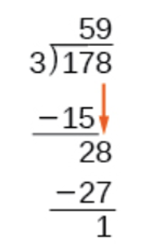Long division for polynomials is very similar to long division of whole numbers. We begin by dividing into the digits of the dividend that have the greatest place value. We divide, multiply, subtract, include the digit in the next place value position, and repeat.

**Long Division**

Step 1: $5×3=15$ and $17-15=2$

Step 2: Bring down the 8

Step 3: $9×3=27$ and $28-27=1$

Answer: 59R1 or $59\frac{1}{3}$

$$\begin{matrix}\text{dividend} & = & \left(\text{divisor}∙\text{quotient}\right)+\text{remainder} \\ 178 & = & \left(3∙59\right)+1 \\ 178 & = & 177+1\end{matrix}$$

For polynomials, the process is very similar and is called the division algorithm. For example, if we were to divide $2x^{3}-3x^{2}+4x+5$ by $x+2$, it would look like:

­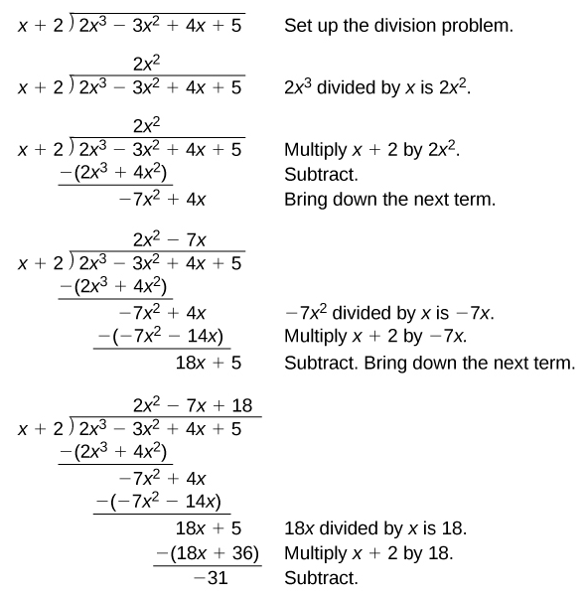

So,

$$\frac{2x^{3}-3x^{2}+4x+5}{x+2}=2x^{2}-7x+18-\frac{31}{x+2}$$

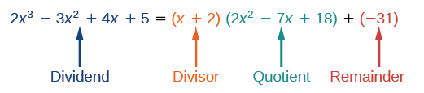

The **Division Algorithm** states that, given a polynomial dividend $f(x)$ and a non-zero polynomial divisor $d(x)$ where the degree of $d(x)$ is less than or equal to the degree of $f(x)$, there exist unique polynomials $q(x)$ and $r(x)$ such that

$$f\left(x\right)=d\left(x\right)q\left(x\right)+r\left(x\right)$$

where $q(x)$ is the quotient and $r(x)$ is the remainder. The remainder is either equal to zero or has degree strictly less than $d(x)$.

If $r\left(x\right)=0$, then $d(x)$ divides evenly into $f(x)$. This means that, in this case, both $d(x)$ and $q(x)$ are factors of $f(x)$.

Given a polynomial and a binomial, use long division to divide the polynomial by the binomial.

1. Set up the division problem.

2. Determine the first terms of the quotient by dividing the leading term of the dividend by the leading term of the divisor.

3. Multiply the answer by the divisor and write it below the like terms of the dividend.

4. Subtract the bottom binomial from the top binomial.

5. Bring down the next term of the dividend.

6. Repeat steps 2-5 until reaching the last term of the dividend.

7. If the remainder is non-zero, express as a fraction using the divisor as the denominator.

Example: Use long division to divide $x^{3}-4x^{2}+2x+5$ by $x-2$

# Using Synthetic Division to Divide Polynomials

As we’ve seen, long division of polynomials can involve many steps and be quite cumbersome.

For example, if we are going to divide $2x^{3}-3x^{2}+4x+5$ by $x+2$, we can get the same answer by either using long division (left image) or by synthetic division (right image).

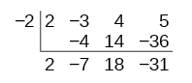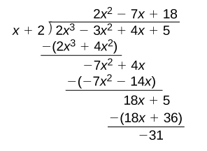

As you can see, synthetic division simplifies the process. In this case, the quotient is $2x^{2}-7x+18$ and the remainder is $-31$.

**Synthetic division** is a shortcut that can be used when the divisor is a binomial in the form $x-k$ where $k$ is a real number. In synthetic division, only the coefficients are used in the division process.

These are the steps in using synthetic division when given two polynomials:

1. Write for the divisor.

2. Write the coefficients of the dividend.

3. Bring the lead coefficient down.

4. Multiply the lead coefficient by $k$. Write the product in the next column.

5. Add the terms of the second column.

6. Multiply the result by $k$. Write the product in the next column.

7. Repeat the last two steps for the remaining columns.

8. Use the bottom numbers to write the quotient. The number in the last column is the remainder and has degree 0, the next number from the right has degree 1, the next number from the right has degree 2, and so on.

Example: Use synthetic division to divide $x^{3}-4x^{2}+2x+5$ by $x-2$.